**Neha Malhotra**  **R.L. Institute M: 9416974837**

**Subject: Biology**

**Topic: Diversity In Living Organisms , Reproduction ,**

**Microbes In Human Welfare**

**M.M. 360 COMPETITIVE TEST**  **Time: 60 Min.**

1. A tooth scraping yields large number of corkscrew shaped bacteria. These bacteria are referred as :

|  |  |  |  |
| --- | --- | --- | --- |
| a) Bacilli | b) Cocci | c) Spirilla | d) Helices |

1. Which bacteria would function best in hot temperatures (45 $°$- 60 $℃$) ?

|  |  |  |  |
| --- | --- | --- | --- |
| a) Psychrophiles | b) Thermophiles | c) Mesophiles | d) all of these |

1. Which of the following statements is/are correct for bacteria?
2. They are the members of kingdom Monera
3. They live in extreme habitats such as hot springs , deserts , snow and deep oceans.
4. They show the most extensive metabolic diversity.
5. All of the above
6. Read the following statements about cyanobacteria and choose the correct option given below.
7. The cyanobacteria are unicellular ,colonial or filamentous , marine or terrestrial bacterium.
8. The colonies of cyanobacteria are generally surrounded by gelatinous sheath

|  |  |  |  |
| --- | --- | --- | --- |
| a) Only (i) | b) (i) and (ii) | c) Only (ii) | d) None of these |

1. Which of the following statements is/are correct for bacteria?
2. They are the members of kingdom Monera
3. They live in extreme habitats such as hot springs , deserts , snow and deep oceans.
4. They show the most extensive metabolic diversity.
5. All of the above
6. Read the following statements about cyanobacteria and choose the correct option given below.
7. The cyanobacteria are unicellular ,colonial or filamentous , marine or terrestrial bacterium.
8. The colonies of cyanobacteria are generally surrounded by gelatinous sheath

|  |  |  |  |
| --- | --- | --- | --- |
| a) Only (i) | b) (i) and (ii) | c) Only (ii) | d) None of these |

1. Amoebic dysentery is caused by :

|  |  |
| --- | --- |
| a) Entamoeba histolytica | b) Entamoeba gingivalis |
| c) Entamoeba coli | d) Amoeba proteus |

1. Match column I and column II

|  |  |  |
| --- | --- | --- |
| Column I | Column II | |
| A. Amoeboid protozoans | I. Paramecium | |
| B. Ciliated protozoans | II. Plasmodium | | |
| C. Flagellated protozoan | III. Amoeba | |
| D. Sporozoans | IV. Trypanosoma | |
| a) A – I ; B – III ; C – IV ; D – II | | | b) A – III ; B – I ; C – II ; D – IV | | |
| c) A – III ; B – I ; C – IV ; D – II | | | d) A – III ; B – IV ; C – I ; D – II | | |

1. Identify the figure and choose the right option :

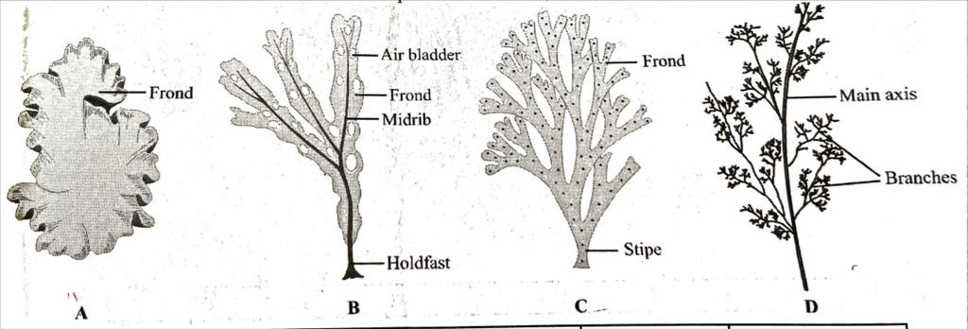

|  |  |  |  |  |
| --- | --- | --- | --- | --- |
|  | A | B | C | D |
| (a) | *Porphyra* | *Dictyota* | *Dictyota* | *Polysiphonia* |
| (b) | *Polysiphonia* | *Porphyra* | *Dictyota* | *Fucus* |
| (c) | *Fucus* | *Dictyota* | *Porphyra* | *Polysiphonia* |
| (d) | *Porphyra* | *Polysiphonia* | *Fucus* | *Dictyota* |

1. Which of the following divisions of fungi includes club fungi?

|  |  |  |  |
| --- | --- | --- | --- |
| a) Zygomycota | b) Ascomycota | c) Deuteromycota | d) Basidiomycota |

1. Dikaryon formation is characteristic of :

|  |  |
| --- | --- |
| a) Ascomycetes and Basidiomycetes | b) Phycomycetes and Basidiomycetes |
| c) Ascomycetes and Phycomycetes | d) Phycomycetes and Zygomycetes |

1. Which of the following statement is a characteristic feature of Chrysophytes?
2. They are parasitic forms which cause diseases in animals.
3. They have a protein rich layer called pellicle.
4. They have indestructible cell wall layer deposited with silica.
5. They are commonly called dinoflagellates
6. The given statements are some characters of a particular group of kingdom protists.
7. Most of them are fresh water organisms found in standing water.
8. They have a protein rich layer (called pellicle) which makes their body flexible.
9. They have two flagella, a short and a long.
10. Though, they are photosynthetic in the presence of sunlight they behave like heterotrophs by predating on other smaller organisms.

Identify the correct group on the basis of these characters.

|  |  |  |  |
| --- | --- | --- | --- |
| a) Protozoans | b) Chrysophytes | c) slime moulds | d) Euglenoids |

1. Identify the given figures :

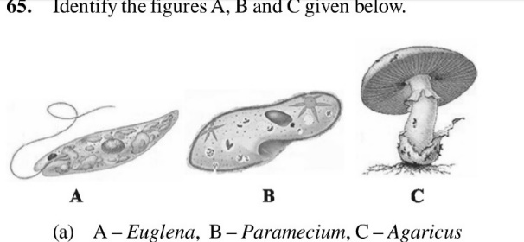

|  |  |
| --- | --- |
| a) A – Euglena ; B – Paramecium ; C – Agaricus | b) A – Euglena ; B – Planaria ; C – Agaricus |
| c) A – Planaria ; B – Paramecium ; C – Agaricus | d) A – Euglena ; B – Paramecium ; C – Aspergillus |

1. The part of the virus which gives to it the genetic feature, is :

|  |  |  |  |
| --- | --- | --- | --- |
| a) Capsid | b) Capsomere | c) Collar sheath | d) Nucleotide |

1. The symbiotic association of fungi and algae is called :

|  |  |  |  |
| --- | --- | --- | --- |
| a) lichen | b) Mycorrhiza | c) Rhizome | d) Endomycorrhiza |

1. Hydrocolloids (water holding substances) produced by certain marine brown and red algae are :

|  |  |  |  |
| --- | --- | --- | --- |
| a) Agar-agar | b) Algin | c) Carrageen | d) Both (b) and (c) |

1. Select the correct match of classes of algae with the number and position of insertion of flagella.

|  |  |
| --- | --- |
| a) Chlorophyceae : 2-8, equal, apical | b) Phaeophyceae : Absent |
| c) Rhodophyceae : 2, unequal, lateral | d) None of these |

1. The following statements are associated with one class of algae. Identify the class of algae.
2. They reproduce sexually by non-motile gametes and asexually by non-motile spores.
3. This class displays sexual reproduction which is oogamous and is accompanied by complex development post-fertilization.
4. *Polysiphonia , Porphyra , Gracilaria and Gelidium* are common members of this class.

|  |  |  |  |
| --- | --- | --- | --- |
| a) Phaeophyceae | b) Chlorophyceae | c) Xanthophyceae | d) Rhodophyceae |

1. The given figures represent few examples of phylum Porifera. Identify the correct name of the figures.

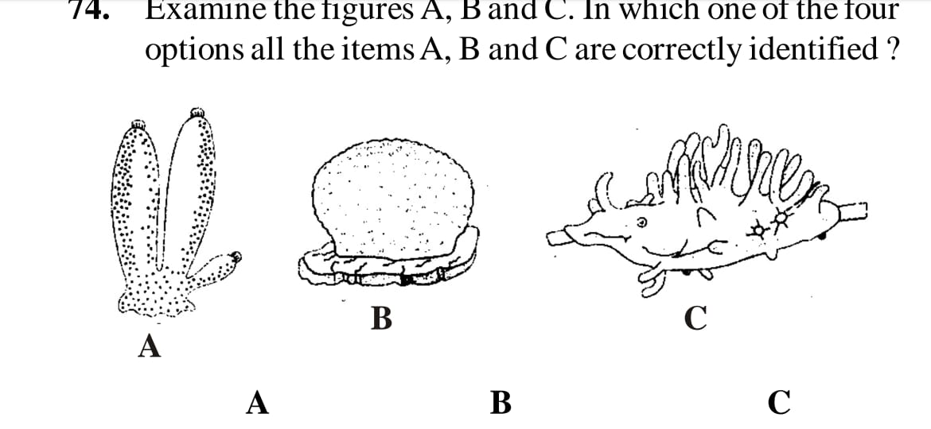

|  |  |  |  |
| --- | --- | --- | --- |
|  | A | B | C |
| (a) | Sycon | Euspongia | Spongilla |
| (b) | Euspongia | Spongilla | Sycon |
| (c) | Spongilla | Sycon | Euspongia |
| (d) | Euspongia | Sycon | Spongilla |

1. The term ‘frond’ in a fern is used for :

|  |  |
| --- | --- |
| a) Rachis | b) whole plant |
| c) Spore bearing leaf | d) Sexually reproducing structures |

1. Identify the vertebrate group of animals characterized by crop and gizzard in its digestive system.

|  |  |  |  |
| --- | --- | --- | --- |
| a) Amphibia | b) Reptilia | c) Osteichthyes | d) Aves |

1. The number of gills that present in Osteichthyes is

|  |  |  |  |
| --- | --- | --- | --- |
| a) 2 pairs | b) 6 – 15 pairs | c) 5 pairs | d) 4 pairs |

1. Perisperm is remaining part of :

|  |  |  |  |
| --- | --- | --- | --- |
| a) Endosperm | b) Ovule | c) Nucellus | d) Integument |

1. Cones and flowers are similar because :

|  |  |
| --- | --- |
| a) Both are bright and showy | b) Both are reproductive organs |
| c) Both do not contain endosperm | d) Both do not contain starch |

1. Identify figure and select correct option :

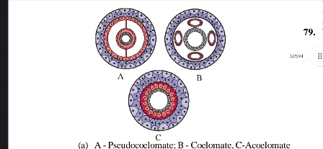

|  |  |  |  |
| --- | --- | --- | --- |
|  | A | B | C |
| (a) | Pseudocoelomate | Coelomate | Acoelomate |
| (b) | Coelomate | Pseudocoelomate | Acoelomate |
| (c) | Coelomate | Acoelomate | Pseudocoelomate |
| (d) | Coelomate | Acoelomate | Eucoelomate |

1. Choose the correct statement about liverworts :
2. In liverworts, the antheridium and archaegonium produce the antherozoids and the egg respectively which fuse during sexual reproduction.
3. Both male and female sex organs may be present on same thalli or different thalli.
4. A sporophyte is formed from the zygote which is differentiated into foot, seta and capsule.
5. Meiosis occur in some cells of the capsule giving rise to haploid spores.

|  |  |  |  |
| --- | --- | --- | --- |
| a) (i) and (iii) | b) (i) , (ii) and (iii) | c) (iii) and (iv) | d) all of these |

1. Read the following statements and choose the correct statements :
2. Funaria possess unicellular and unbranched rhizoids.
3. Mosses along with lichens are the first organisms to colonise rocks.
4. Gemmae are asexual buds, which originate from small receptacles called gemma cup.
5. Sphagnum plants have magnification property of retaining water.

|  |  |  |  |
| --- | --- | --- | --- |
| a) All of these | b) (i) , (iii) and (iv) | c) (ii) , (iii) and (iv) | d) (i) , (ii) and (iii) |

1. Which of the following statements is/are correct about pteridophytes:
2. The main plant body is a sporophyte which is differentiated into true roots and leaves.
3. The leaves are small (microphylls) as in fern or large (macrophylls) as in Selaginella.
4. Genera like Selaginella and Salvinia which produce two kinds of spores – Macro and micro spores, known as heterosporous.
5. Common examples are : Funaria , Polytrichum and Sphagnum.

|  |  |  |  |
| --- | --- | --- | --- |
| a) (i) and (ii) | b) (ii) and (iii) | c) (i) and (iii) | d) all of these |

1. Coralloid root of Cycas are useful in :

|  |  |  |  |
| --- | --- | --- | --- |
| a) N2 ­fixation | b) absorption of water | c) transpiration | d) all of these |

1. Pseudocoelom found in :

|  |  |  |  |
| --- | --- | --- | --- |
| a) *Ascarias* | b) *Hydra* | c) *Taenia* | d) *Leucosolenia* |

1. Animals with metameric segmentation, bilateral symmetry and closed circulatory system belongs to phylum:

|  |  |  |  |
| --- | --- | --- | --- |
| a) Annelida | b) Echinodermata | c) Arthropoda | d) Mollusca |

1. Which of the following characteristics distinguish Arthropoda from annelids and molluscs?
2. An external skeleton made up of chitin and protein rather than a shell made chiefly of mineral salts.
3. subdivisions of the legs into movable segments.
4. Distinct group of muscles, derived from many body segments, that move the separate parts of exoskeleton.
5. all the above
6. Electric organs occur in :

|  |  |  |  |
| --- | --- | --- | --- |
| a) Sharks | b) Goldfish | c) Porpoises | d) Rays |

1. Scoliodon is called dog fish because of its :

|  |  |  |  |
| --- | --- | --- | --- |
| a) Carnivorous nature | b) Long mouth | c) Power of smell | d) all of these |

1. Which of the following phylum is being described by given statements?
2. They are bilaterally symmetrical , Triploblastic , segmented and coelomate animals.
3. The body consists of head, thorax , abdomen and have jointed appendages.
4. Circulatory system is open type
5. Excretion takes place by Malpighian tubules.

|  |  |  |  |
| --- | --- | --- | --- |
| a) Arthropoda | b) Annelida | c) mollusca | d) Echinodermata |

1. An important characteristics that hemichordates share with chordates is :

|  |  |  |  |
| --- | --- | --- | --- |
| a) ventral tubular nerve cord | b) pharynx with gill slits | c) pharynx without gill slits | d) absence of notochord |

1. Which of the following features is not present in phylum Arthropoda?

|  |  |  |  |
| --- | --- | --- | --- |
| a) chitinous exoskeleton | b) metameric segmentation | c) parapodia | d) joint appendages |

1. Sperm become motile in human being in :

|  |  |  |  |
| --- | --- | --- | --- |
| a) Seminiferous tubules | b) Vas deferens | c) Epididymis | d) Seminal vesicle |

1. The first movement of the foetus and appearance of hair on its head are usually observed during which month of pregnancy?

|  |  |  |  |
| --- | --- | --- | --- |
| a) 5th month | b) 6th month | c) 3rd month | d) 4th month |

1. The correct sequence of embryonic development is :

|  |  |
| --- | --- |
| a) Blastula $→$ Morula $→$ Zygote $→$ Gastrula $→$ Embryo | b) Zygote $→$ Blastula $→$ Morula $→$ Gastrula $→$ Embryo |
| c) Zygote $→$ Morula $→$ Blastula $→$ Gastrula $→$ Embryo | d) Gastrula $→$ Morula $→$ Zygote $→$ Blastula $→$ Embryo |

1. Sertoli cells are regulated by the pituitary hormone known as :

|  |  |  |  |
| --- | --- | --- | --- |
| a) LH | b) FSH | c) GH | d) Prolactin |

1. Clitoris in female mammals is :

|  |  |
| --- | --- |
| a) Homologous to penis of male | b) Analogous to penis of male |
| c) Non-functional | d) Overgrown structure |

1. Sperms formed form 4 primary spermatocytes are :

|  |  |  |  |
| --- | --- | --- | --- |
| a) 4 | b) 1 | c) 16 | d) 32 |

1. Which of the following are haploid in nature?

(A) Spermatids (B) Secondary spermatocytes (C) Spermatogonia (D) Primary spermatocytes

|  |  |  |  |
| --- | --- | --- | --- |
| a) A , B and C are correct | b) A and B are correct | c) B and D are correct | d) A and C are correct |

1. The diaphragm , Vaults and cervical caps are :

|  |  |
| --- | --- |
| a) Disposable contraceptive devices | b) Reusable contraceptive devices |
| c) IUDs | d) Implants |

1. Copper – T is a device that prevents :

|  |  |  |  |
| --- | --- | --- | --- |
| a) implantation of blastocyst | b) ovulation | c) fertilization | d) egg maturation |

1. The best way to control population of a country is :

|  |  |
| --- | --- |
| a) To educate people | b) To have better house |
| c) To kill people on a large scale | d) To practice and implement family planning s |

1. Identify the indicators that signify improved reproductive health of a society.

|  |  |
| --- | --- |
| a) Improved detection and cure for STDs | b) Improve medical facilities. |
| c) Decrease in infant and maternal mortality rate | d) All of the above |

1. Largest nucleus in pollen grain of flowering plants id :

|  |  |  |  |
| --- | --- | --- | --- |
| a) Tube nucleus | b) Sperm nucleus | c) Generative nucleus | d) None of these |

1. Ploidy level of synergids are :

|  |  |  |  |
| --- | --- | --- | --- |
| a) Haploid | b) Diploid | c) Triploid | d) Tetraploid |

1. Apomixis is common in :

|  |  |  |  |
| --- | --- | --- | --- |
| a) Asteracy | b) Grasses | c) Both (a) & (b) | d) Solanaceae |

1. A diploid male angiospermic plant is crossed with tetraploid female plant. Endosperm in seed will be :

|  |  |  |  |
| --- | --- | --- | --- |
| a) Haploid | b) Triploid | c) tetraploid | d) Pentaploid |

1. Type of pollination in Commelina is :

|  |  |  |  |
| --- | --- | --- | --- |
| a) Chasmogamy | b) Autogamy | c) Xenogamy | d) Cleistogamy |

1. Select the correct order of endosperm types:

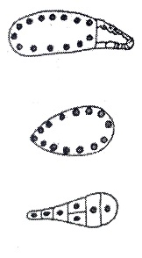

|  |  |
| --- | --- |
| a) Cellular , Helobial , Free nuclear | b) Cellular , Free nuclear , Helobial |
| c) Helobial , Free nuclear , Cellular | d) Free nuclear , Cellular , Helobial |

1. Vegetative fertilization is also called as

|  |  |  |  |
| --- | --- | --- | --- |
| a) Triple fusion | b) True fertilization | c) Syngamy | d) Generative fertilization |

1. Endosperm is completely consumed by :

|  |  |
| --- | --- |
| a) pea , ground nut and castor | b) ground nut , bean and coconut |
| c) pea , ground nut and bean | d) None of the above |

1. Which one of the following statements is correct?

|  |  |
| --- | --- |
| a) Cleistogamous flowers are always autogamous | b) Xenogamy occurs only by wind pollination |
| c) Chasmogamous flowers do not open at all | d) Geitonogamy floral are of different plants |

1. Pollination in water hyacinth and water lily is brought about by the agency of

|  |  |  |  |
| --- | --- | --- | --- |
| a) Birds | b) Bats | c) Water | d) Insects or wind |

1. Pollen grain can be stored for several years in liquid nitrogen having a temperature of :

|  |  |  |  |
| --- | --- | --- | --- |
| a) – 80˚C | b) – 196˚C | c) – 120˚C | d) – 160˚C |

1. An example of sexual deceit is exhibited by :

|  |  |  |  |
| --- | --- | --- | --- |
| a) Salvia | b) Ficus | c) Ophrys | d) None of these |

1. The wheat grain has an embryo with one large, shield-shaped cotyledon known as :

|  |  |  |  |
| --- | --- | --- | --- |
| a) Epiblast | b) Coleorhiza | c) Scutellum | d) Coleoptile |

1. Swiss cheese is formed by bacterium?

|  |  |
| --- | --- |
| a) Aspergillus niger | b) Lactobacillus |
| c) Propionibacterium shermanii | d) Penicillium roqueforti |

1. Who observed a mould growing in unwashed culture plate while working on Staphylococcus bacterium?

|  |  |  |  |
| --- | --- | --- | --- |
| a) Ernest chain | b) Alexander Flemming | c) Lamarck | d) Florey |

1. Identify the blank space given in following table:

|  |  |  |
| --- | --- | --- |
| Types of microbes | Scientific names | Commercial products |
| Bacterium | A | Lactic acid |
| Fungus | B | Citric acid |
| C | Acetobacter aceti | Acetic acid |
| Fungus | Penicillium notatum | D |

1. A – Lactobacillus ; B – Aspergillus niger ; C – Bacterium ; D – Penicillin
2. A – Staphylococcus ; B – Clostridium ; C – Yeast ; D – Penicillin
3. A – Lactobacillus ; B – Microsporum ; C – Yeast ; D – Penicillin
4. A – Staphylococcus ; B – Microsporum ; C – Agaricus ; D – Penicillin
5. Which one of the following is correctly matched for the product produced by them?

|  |  |
| --- | --- |
| a) Acetobacter aceti – Antibiotics | b) Methanobacterium – Lactic acid |
| c) Penicillium notatum – Acetic acid | d) Saccharomyces cerevisiae – Ethanol |

1. Which of the following statement is correct?
2. Ethanol is produced by fermentation of malted cereals and fruit juices.
3. Wine is produced without distillation.
4. Saccharomyces is used for bread making.
5. All of the above
6. In the primary treatment of sewage, the soil and small pebbles are removed by :

|  |  |  |  |
| --- | --- | --- | --- |
| a) Filtration | b) Sedimentation | c) Condensation | d) Evaporation |

1. Given below is the flowchart of sewage treatment. Identify A , B , C , D and E , select the correct option:

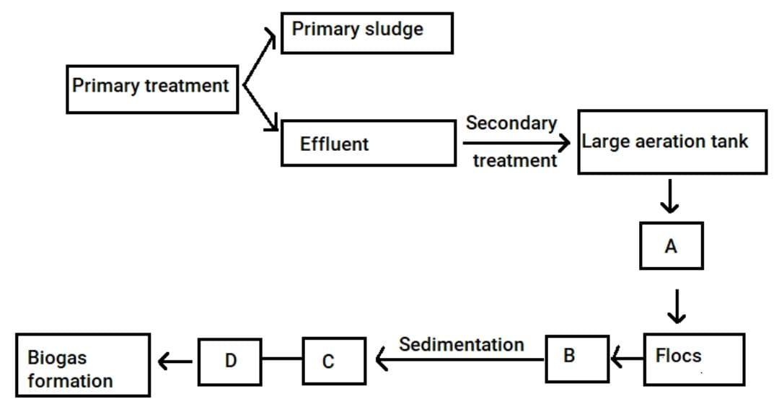

1. A – Small aerated tank ; B – Microbial digestion ; C – High BOD ; D – Activated sludge ; E – Aerobic sludge digester.
2. A – Large aerated tank ; B – Mechanical agitation ; C – High BOD ; D – Activated sludge ; E – Aerobic sludge digester.
3. A – Small aerated tank ; B – Microbial digestion ; C – Low BOD ; D – Activated sludge ; E – Anaerobic sludge digester.
4. A – Large aerated tank ; B – Mechanical agitation ; C – Reduced BOD ; D – Activated sludge ; E – Anaerobic sludge digester.
5. Which of the following is cyanobacteria and fix atmospheric nitrogen?

|  |  |  |  |
| --- | --- | --- | --- |
| a) Oscillatoria | b) Nostoc | c) Anabaena | d) All of these |

1. Which of the following is common to Azospirillum , Anabaena , Nostoc and Oscillatoria?

|  |  |  |  |
| --- | --- | --- | --- |
| a) N2 fixer microbes | b) prokaryotic organisms | c) Eukaryotic organisms | d) Both (a) and (b) |

1. Which of the following serves as biofertilizers in paddy fields ?

|  |  |  |  |
| --- | --- | --- | --- |
| a) Anabaena | b) Azospirillum | c) Nostoc | d) Both (a) and (c) |

1. Read the following statements and select the correct statements:
2. Biocontrol agents refers to the use of biological methods for controlling plant diseases and pests.
3. Use of biocontrol measures will greatly reduce our dependence on toxin chemicals and pesticides.

|  |  |
| --- | --- |
| a) Both statement (i) and (ii) are correct. | b) Statement (i) is correct & statement (ii) incorrect |
| c) Statement (i) is incorrect & statement (ii) correct | d) Both statement (i) and (ii) are incorrect |

1. Read the following statements about disadvantages of chemical agents.
2. Chemicals are toxic and harmful to human beings and animals.
3. Chemicals pollute the environment and forests.
4. Weedicides used to remove weeds also pollute the soil.

Select the correct options:

|  |  |  |  |
| --- | --- | --- | --- |
| a) (i) , (ii) , (iii) | b) (i) , (ii) | c) (i) , (iii) | d) (ii) , (iii) |

1. Which of the following is used as clot buster for removing clot.

|  |  |  |  |
| --- | --- | --- | --- |
| a) ethanol | b) Statins | c) Cyclosporin - A | d) Streptokinase |

1. Identify the blank space in the given table:

|  |  |  |  |
| --- | --- | --- | --- |
| Types of microbes | Scientific name | Products | Medical applications |
| Fungus | A | Cyclosporin – A | B |
| C | Monascus purpureus | Statin | D |

1. A – Trichoderma polysporum ; B – Used as an immunosuppressive agent ; C – yeast ; D – Blood cholesterol lowering agent.
2. A – Trichoderma polysporum ; B – Blood cholesterol lowering agent ; C – Protozoa ; D – Used as an immunosuppressive agent.
3. A – Clostridium butylicum ; B – Used as clot buster ; C – yeast ; D – Blood cholesterol lowering agent.
4. A – Clostridium butylicum ; B – Blood cholesterol lowering agent ; C – yeast ; D – Used as clot buster.
5. Ejaculation of human male contains about 200 – 300 millions sperms, of which for normal fertility _____% sperms must have normal shape and size and at least ______ % must show energetic motility.

|  |  |  |  |
| --- | --- | --- | --- |
| a) 40 , 60 | b) 50 , 50 | c) 60 , 40 | d) 30 , 70 |

1. Medical termination of pregnancy is safe upto :

|  |  |
| --- | --- |
| a) 8 weeks of pregnancy | b) 12 weeks of pregnancy |
| c) 18 weeks of pregnancy | d) 24 weeks of pregnancy |

1. Hormone responsible for the secretion of milk after parturition is :

|  |  |  |  |
| --- | --- | --- | --- |
| a) ICSH | b) prolactin | c) ACTH | d) LH |

1. Atretic follicle are found in the :

|  |  |  |  |
| --- | --- | --- | --- |
| a) fallopian tubes | b) uterus | c) labia majora | d) ovary |

1. Colostrum, the yellowish fluid secreted by mother during the initial days of lactation is very essential to impart immunity to the new born infants because it contains:

|  |  |  |  |
| --- | --- | --- | --- |
| a) immunoglobulin A | b) natural killer cells | c) monocytes | d) macrophages |

1. Milk secreted from the cells of alveoli of mammary lobes reaches nipple through lactiferous duct (L), mammary duct (M) , mammary tubule (T) and mammary ampulla (A) in the following order:

|  |  |  |  |
| --- | --- | --- | --- |
| a) TMAL | b) MTLA | c) MTAL | d) ATML |

1. Emergency contraceptives are effective if used with in

|  |  |  |  |
| --- | --- | --- | --- |
| a) 72 hrs of coitus | b) 72 hrs of ovulation | c) 72 hrs of menstruation | d) 72 hrs of implantation |

1. Lactation amenorrhoea means

|  |  |
| --- | --- |
| a) absence of menstruation during pregnancy | b) absence of menstruation during lactation |
| c) excessive bleeding during menstruation | d) no production and secretion of milk |

1. Amniocentesis is a process to

|  |  |
| --- | --- |
| a) grows of cells on the culture medium | b) determine any hereditary diseases of embryo |
| c) know about the diseases of brain | d) determine any diseases of heart |

1. ICBN stands for

|  |  |
| --- | --- |
| a) International Code of Botanical Nomenclature | b) International Congress of Biological Names |
| c) Indian Code of Botanical Nomenclature | d) Indian Congress of Biological Names |

1. The taxonomic unit ‘Phylum’ in the classification of animals is equivalent to which hierachial level in classification of plants

|  |  |  |  |
| --- | --- | --- | --- |
| a) Class | b) Order | c) Division | d) Family |

1. The first step in classification of organism is

|  |  |
| --- | --- |
| a) Identification | b) Description |
| c) Sorting out distinguishing traits | d) Use of keys |

1. The term species was introduced by

|  |  |  |  |
| --- | --- | --- | --- |
| a) John ray | b) Linnaeus | c) Theophrastus | d) Pliny |

1. Taxon is unit of

|  |  |  |  |
| --- | --- | --- | --- |
| a) Species | b) Genus | c) Order | d) Taxonomy |